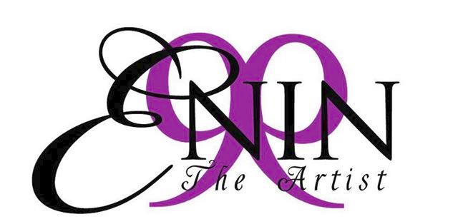
ABOUT ENIN PERRYMAN
“The Man Behind The Microphone”
Rev. Dr. Enin Perryman, A.A., B.S.H.S., M.H.A., D. Div. stage known as
“ENIN THE ARTIST”, was born in Chicago, Illinois, reared in Clarksdale, Mississippi and currently resides in Rock Hill, SC. A Recording Artist with a style sure to capture the essence of the soulful ears of a multi-genre of listeners.

His rich sound and alluring lyrics bring a musical blend of Rhythm and Blues, paired with Gospel, the story telling qualities of Country Music all fused into a fresh sound that shows his rich Mississippi Delta influence and rearing.

Singing in rural churches since the tender age of five, his grandmother picked up that there was something different and very special about Enin; He was groomed for music success and graduated from the Fresno High School of the Arts (Fresno, California).

After High School, Enin decided to take on a different path as he enlisted in the U.S. Army serving in the Gulf War, yet building a European following for his music while touring Europe and gaining fans and supporters throughout the world.

As a singer and songwriter his talents have afforded him opportunities and notoriety with many recording artists, music producers, and industry heads to include performances and collaborations with: R. Kelly, Paris Red, Freddie Jackson, Rev. Al Green, Chuckii Booker, Pattie Labelle, Boyz II Men, Roger and Zap, Larry Gettens of Cool and the Gang, Usher, D Angelo, DRS, Prince, Joe, Silk, Tevin Campbell, Damien Hall, Portrait, Special Generation, Quincy Jones, Brian McKnight, Snoop Dogg, Brandy and the American Music Awards.

Rev. Dr. Enin Perryman is well accomplished and holds multiple Degrees as a Graduate of East Mississippi Community College with an Associate of Arts Degree in General Education, Kaplan University, Ft Lauderdale, FL, holding a B.S. Degree in Health Sciences, The University of Canterbury, UK, holding his Doctorate in Divinity, a Masters of Health Administration at Capella University and is currently matriculating in the Doctoral program in Health Administration at Capella as well, leading up to a Double PhD.

He relocated to Rock Hill, South Carolina in September 2013 to pursue his entry into the Ministry for our Lord Jesus and is now the Founder and Pastor of
N-TYME/OPENDOOR Ministries Inc. located in Charlotte, North Carolina.

His favorite passage of scripture sums up his mission of hope, Acts 2:38 (KJV) ³⁸ Then Peter said unto them, Repent, and be baptized every one of you in the name of Jesus Christ for the remission of sins, and ye shall receive the gift of the Holy Ghost.
Stay Tuned for the summer single release entitled “Sunshine” along with an EP (Prayer Room) and a full length
CD project (Point of it All Volume 1) of songs, all written and performed by none other than “Enin”.

^^^^^^^^^^^^^^^^^^^^^^^^^^^^^^^^^^^^^^^^^^^^^^^^^^^^^^^^^^^^^^^^
For Bookings, Speaking, Interviews and Management Contact:
A.C.T.S. ENTERTAINMENT MANAGEMENT
EMAIL: actsmanagement@live.com
Phone: (404) 432-7648
Mailing Address: PO BOX 22853 Nashville, TN 37202

